# Windows Guide for installing cLab app and its dependencies

Step 1: Get the cLab installer named “**VLab 1.5.4 bundle.exe**” (Its size is over 700 MB). Access the file using LDAP from this [link](https://drive.google.com/drive/folders/1hXk_7kaWA71WSfltraeLEIzKlHs0ns1Z).

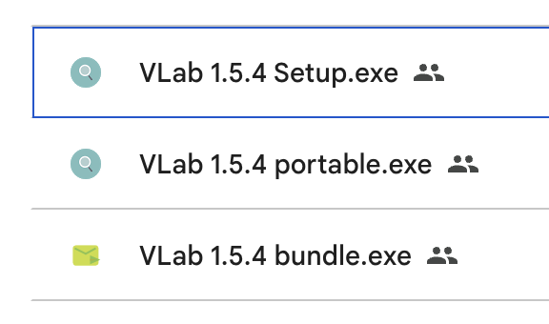

Step 2: Double-click the .exe to run the installer. You may see this window =>

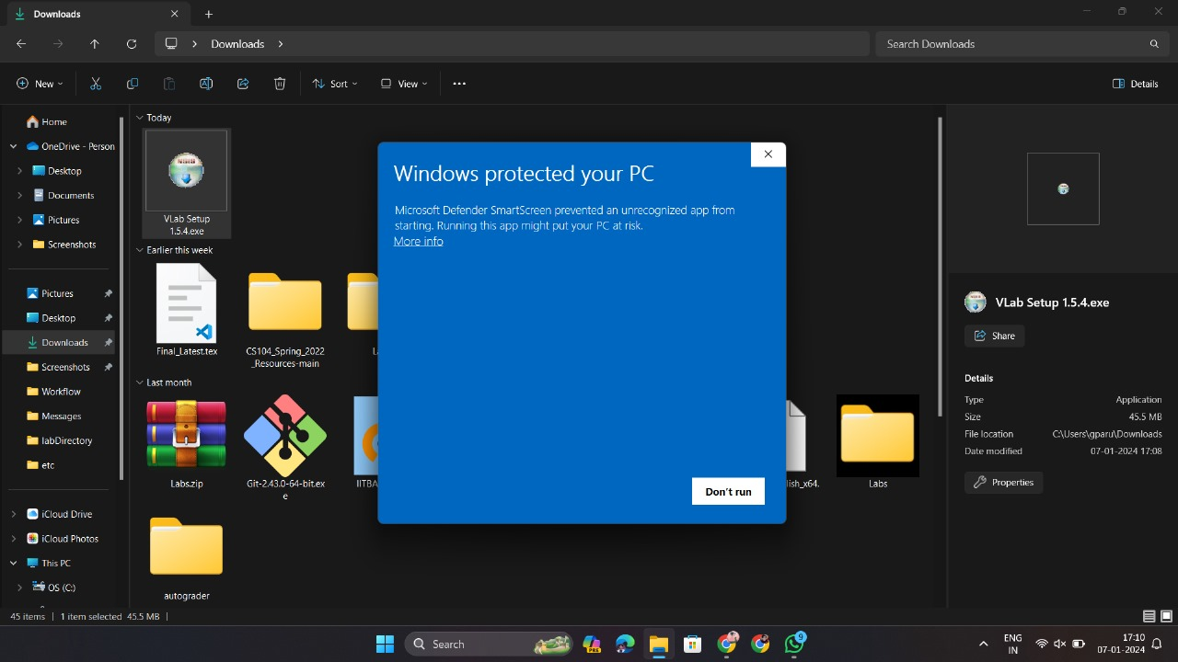

If you see this window, follow the instructions in Steps 3 and 4; otherwise, skip to Step 5.

Step 3: Click “More Info” =>



Step 4: Click the “Run Anyway” button =>

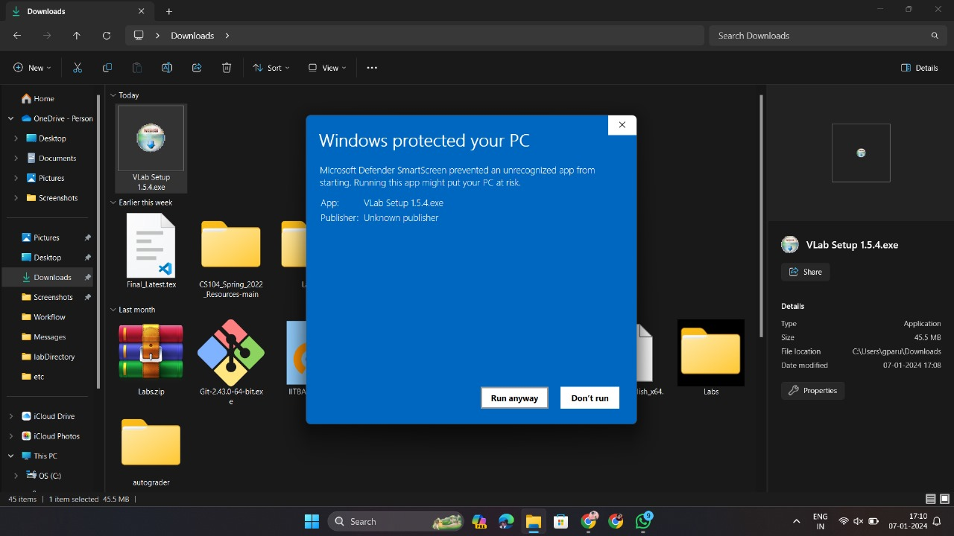

Step 5: You’ll see this window. Click “Yes” =>

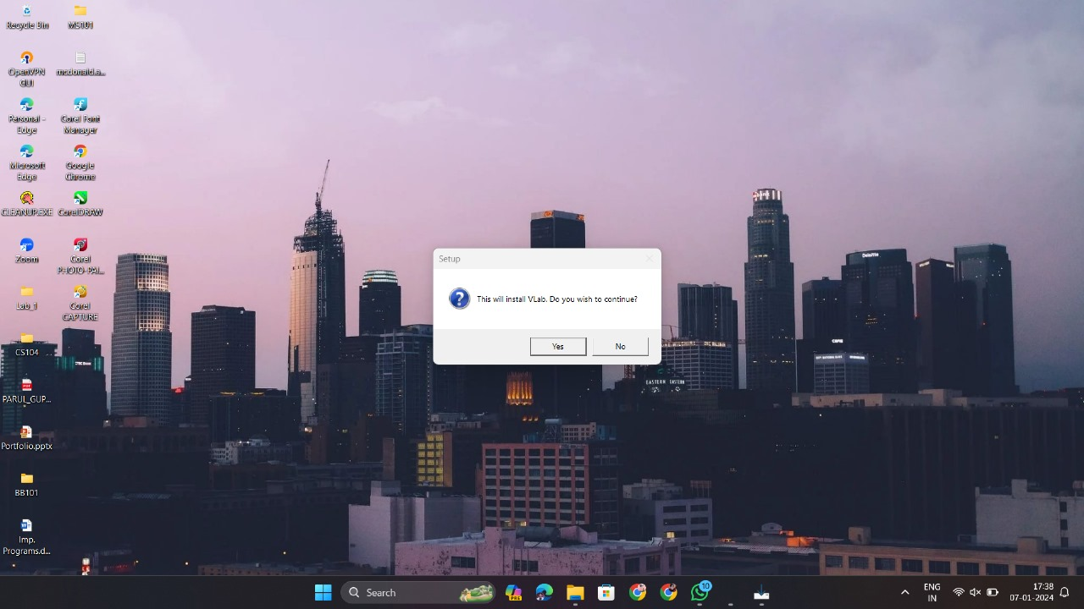

Step 6: You’ll see this window. Click “Next” =>

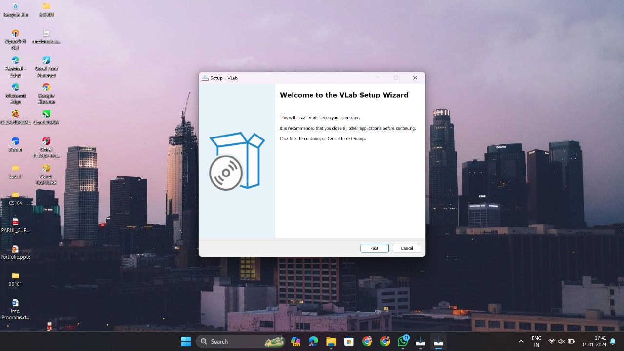

Step 7: Accept the agreement and click “Next” =>

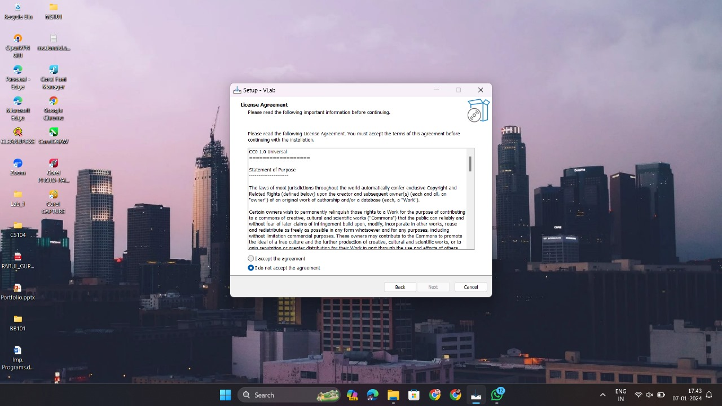

Step 8: Set the path of installation (preferred to leave it as the given default). Ensure you have sufficient storage space on that path (mentioned at the bottom of this window). Then click “Next” =>

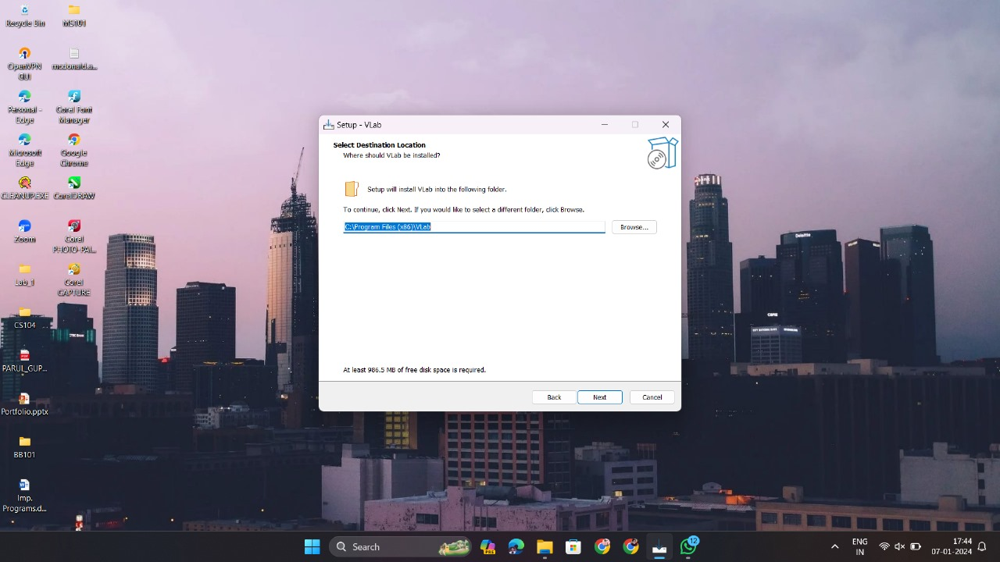

Step 9: You can choose to create a desktop shortcut or not. Then click “Next” =>

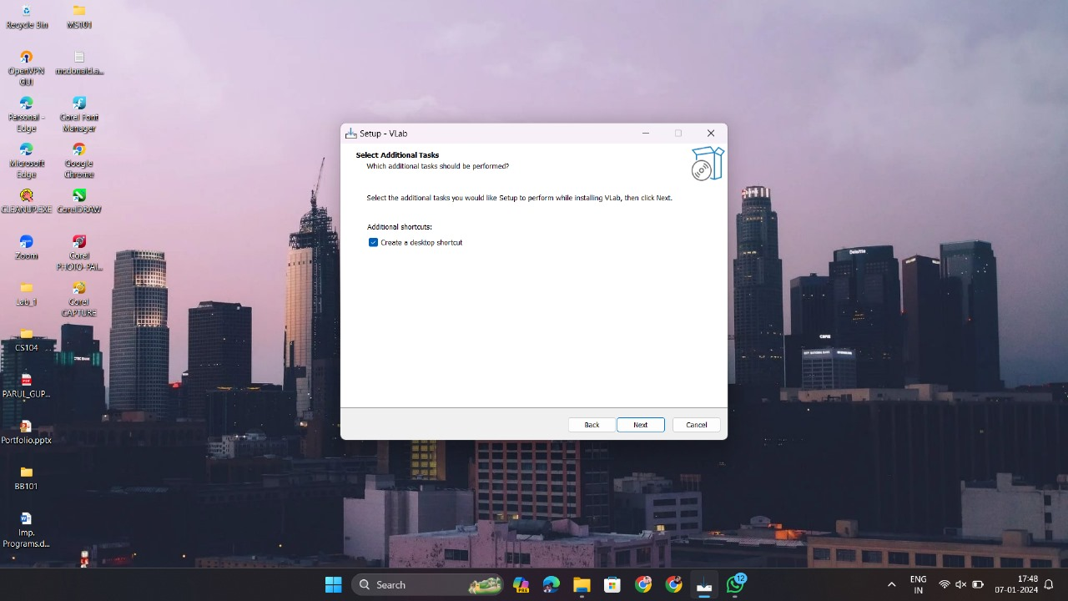

Step 10: You can see that many additional dependencies are going to be downloaded by this installer. Click Install =>

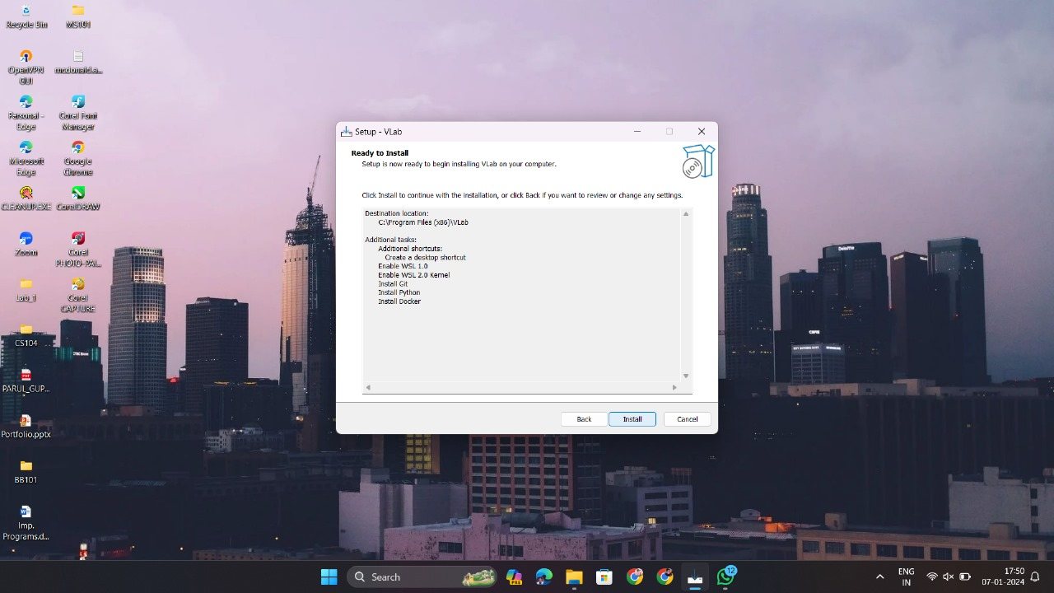

You will then see a progress bar like this =>

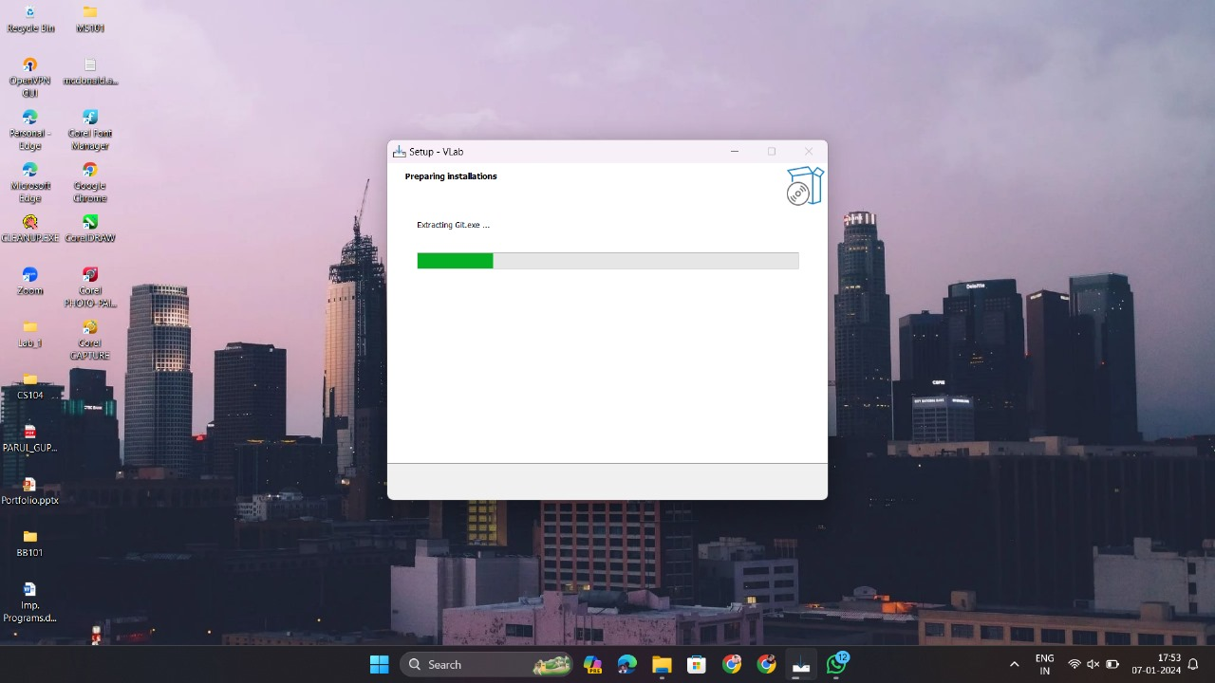

Step 11: If WSL2 is not enabled on your machine, the installer will automatically do it. You may see a window like =>

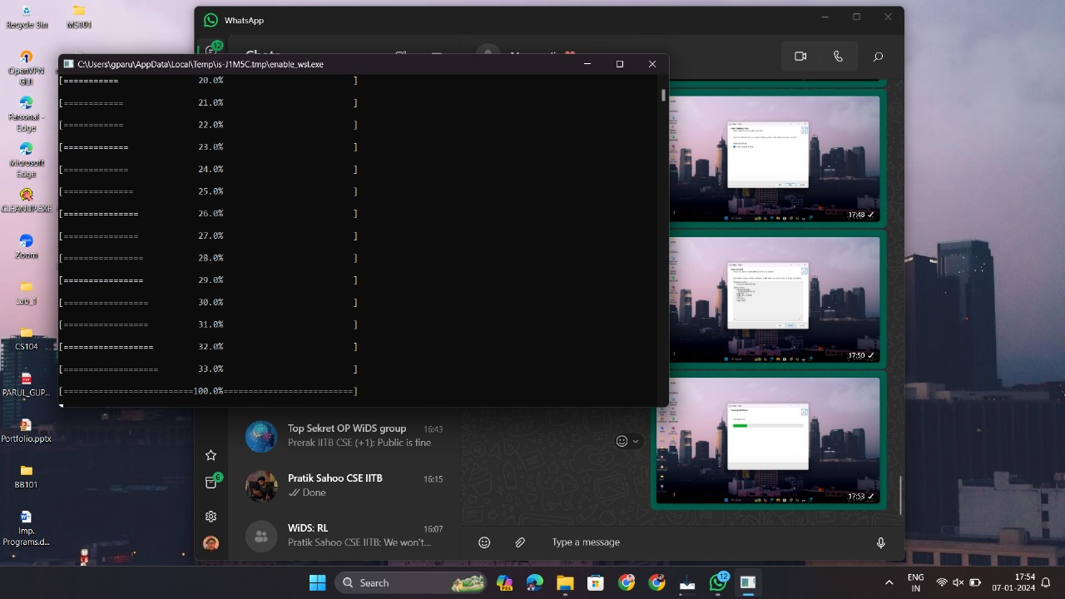

After completing this, the above window closes, and you will see this window. Click “Finish” to proceed =>

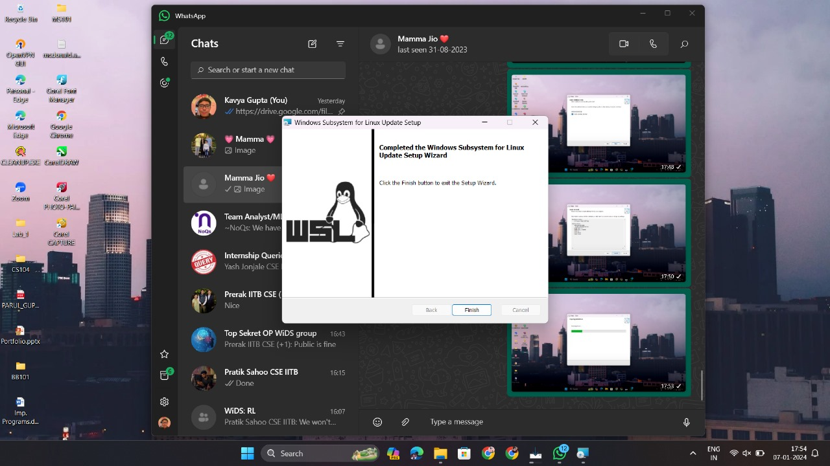

WSL2 is successfully enabled.

Step 12: If git is not installed on your machine, the installer will open the setup. Keep clicking “Next” to proceed with a series of windows. It is preferred to let the settings be the given default =>

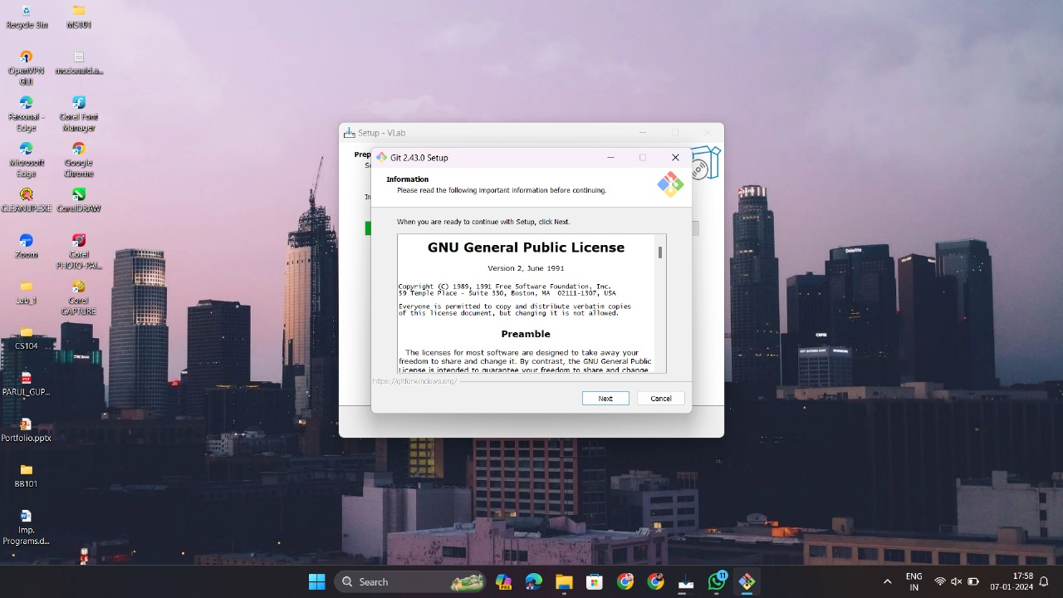

In a final window for the git, you will see “Install”, click that, and you may see this window =>

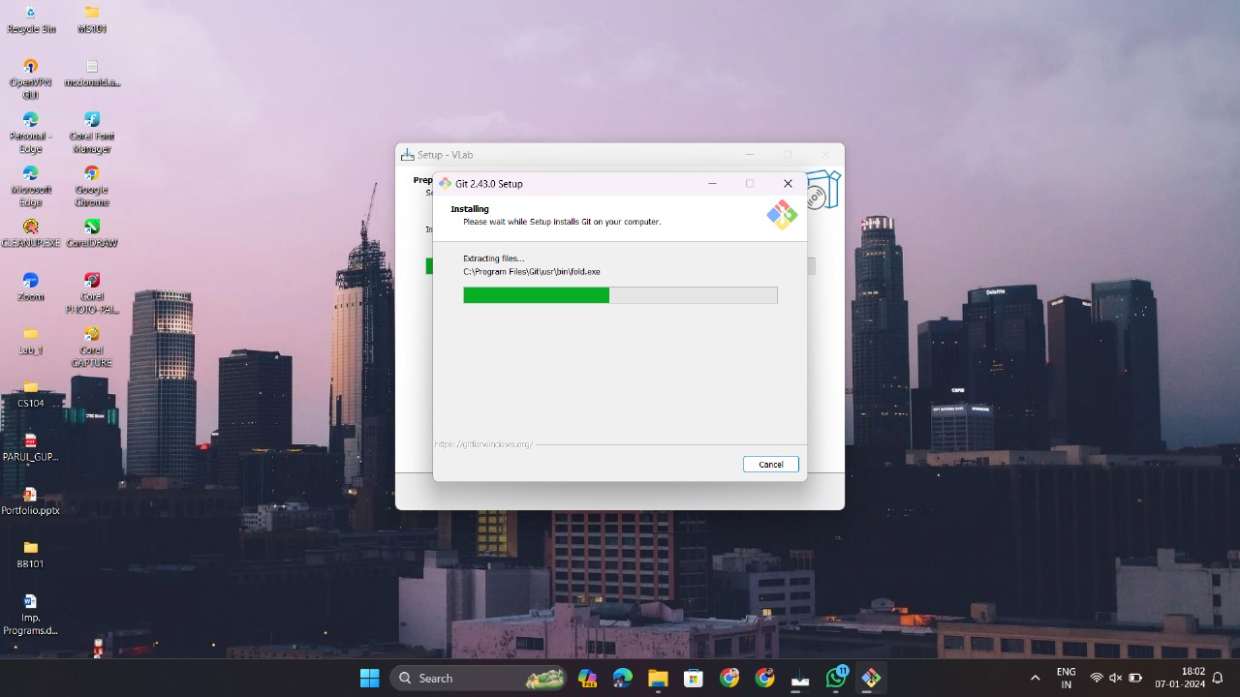

After completing this, you will see this window. Uncheck the “View Release Notes” checkbox and then click “Finish” to proceed =>

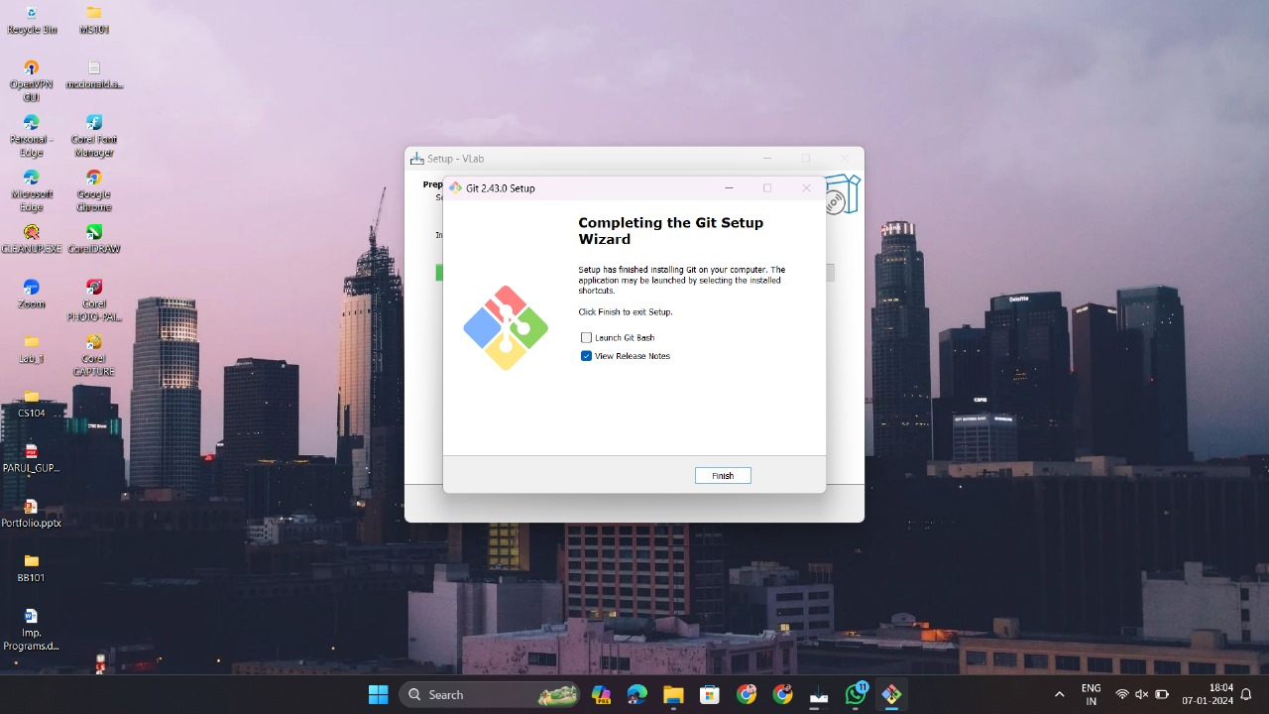

Now, git is successfully installed.

Step 13: The installer will open a setup if Python is not installed on your machine. Check **BOTH** the “Use admin privileges” and “Add python.exe to PATH” checkboxes and click “Install Now” =>

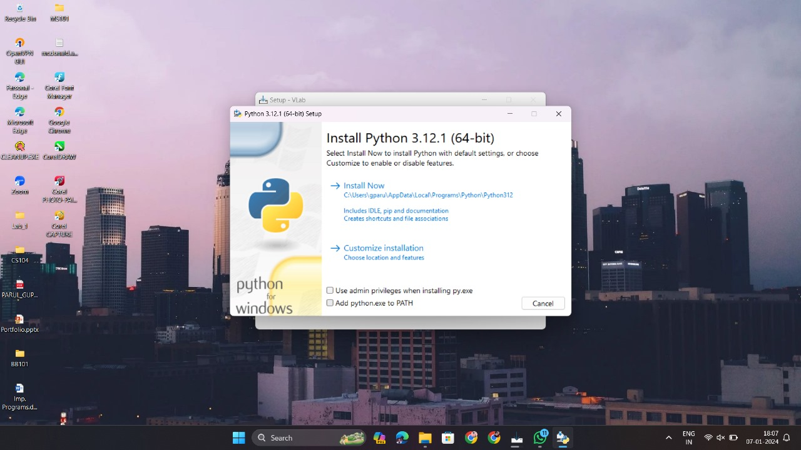

You will see a progress bar like =>

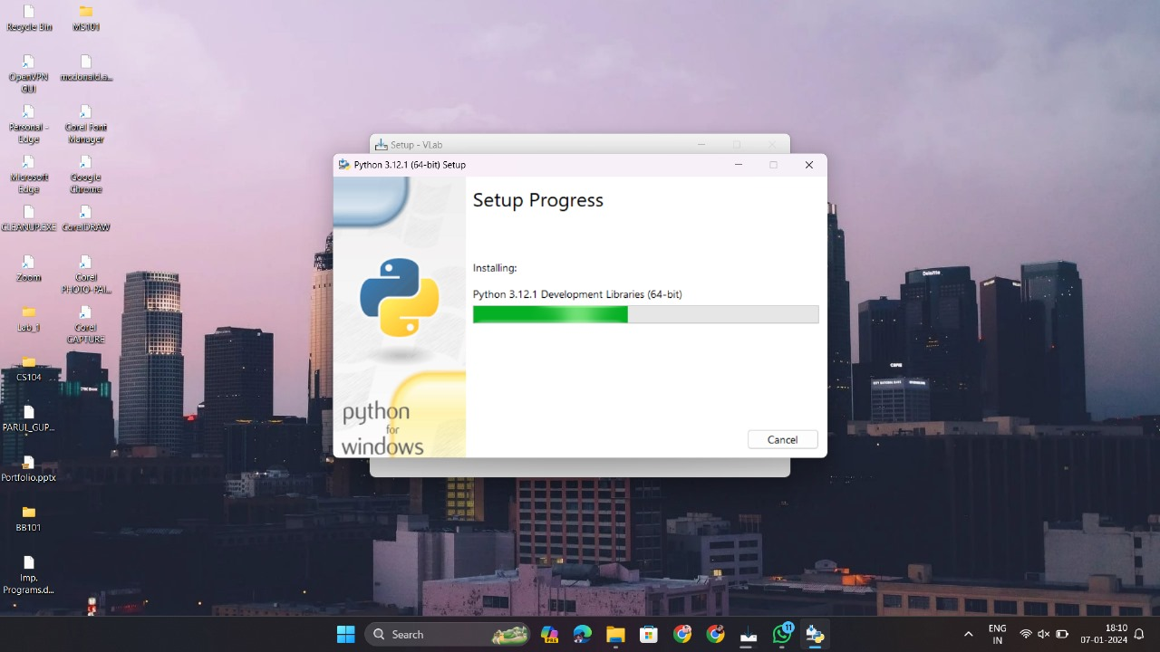

After completing this, you will see this window. Click “Close” to proceed =>

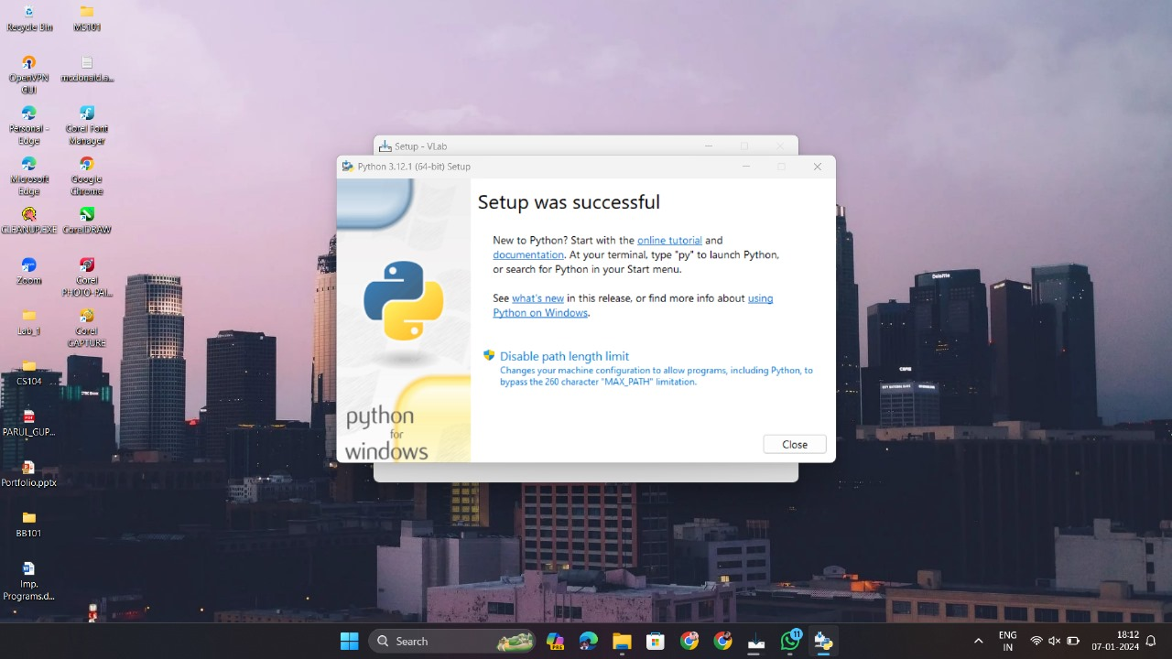

Now, python is successfully installed.

Step 14: Now, the installer will open the setup for the Docker Desktop application. You will see this window. Click “Ok” to proceed =>

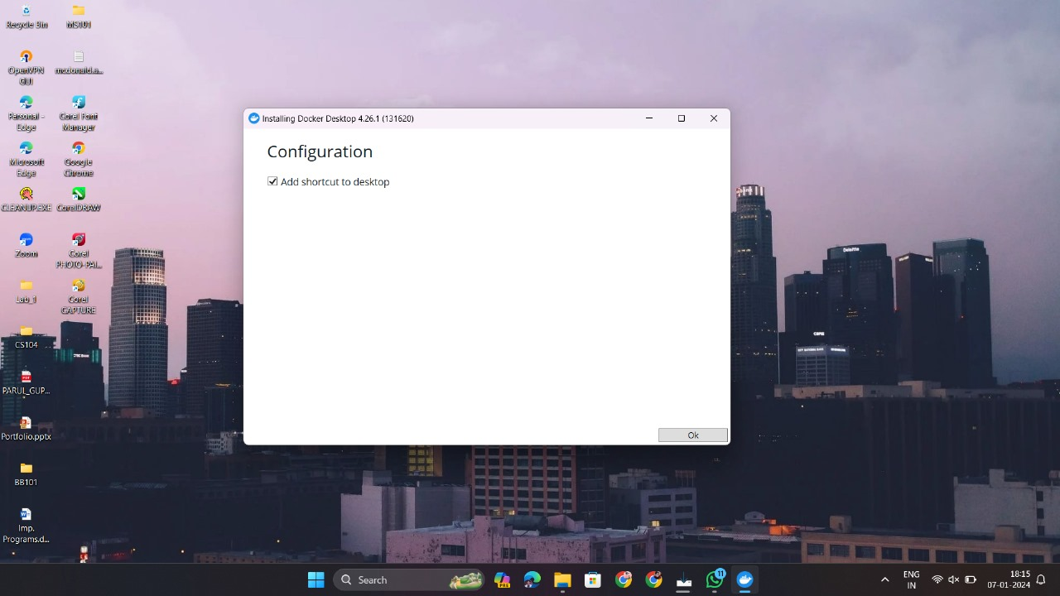

You will now see this window. This can take some time. Please wait for a few minutes patiently =>

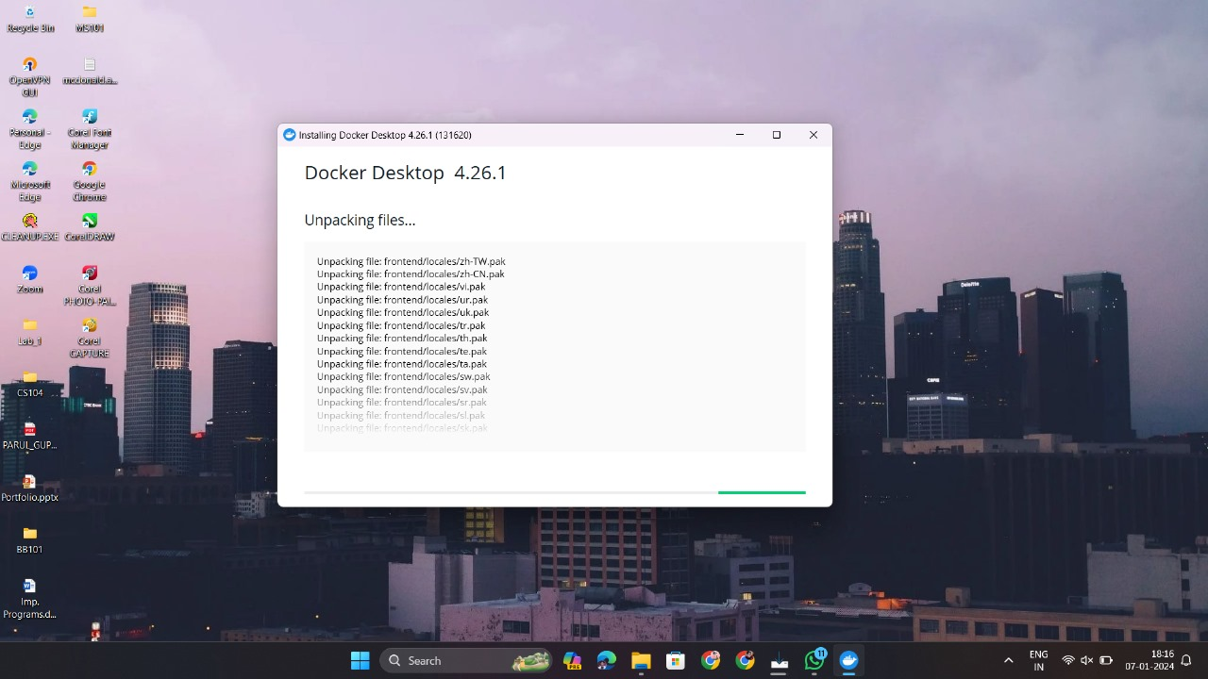

After completing this, you will see this window. Click “Close” =>

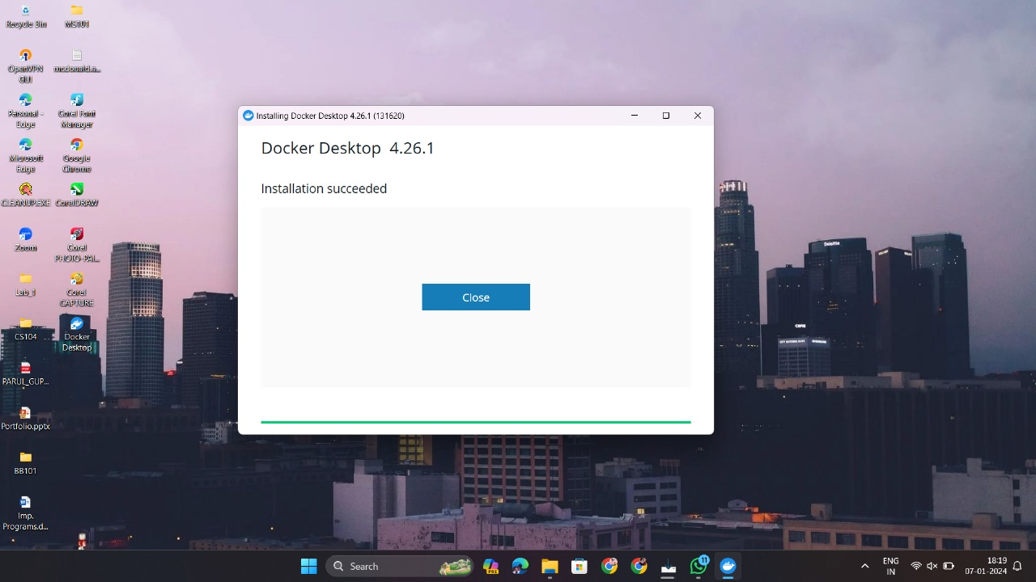

Instead if you see this window, just click on “X” on the top-right =>

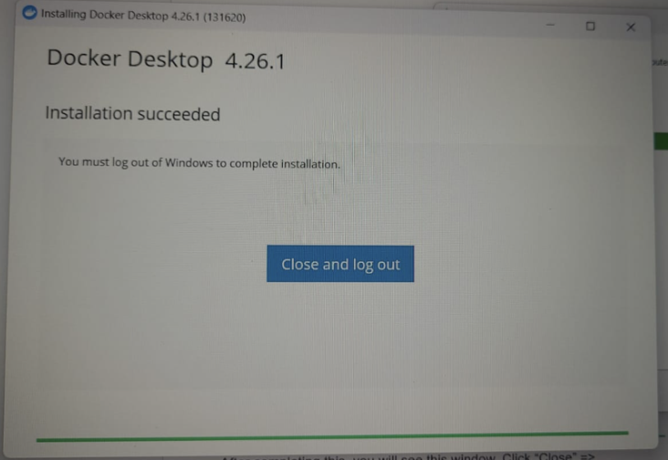

Now, the Docker Desktop is successfully installed.

Step 15: Now, all the dependencies have been downloaded. The installer will now install the cLab app. You may see a progress bar like =>

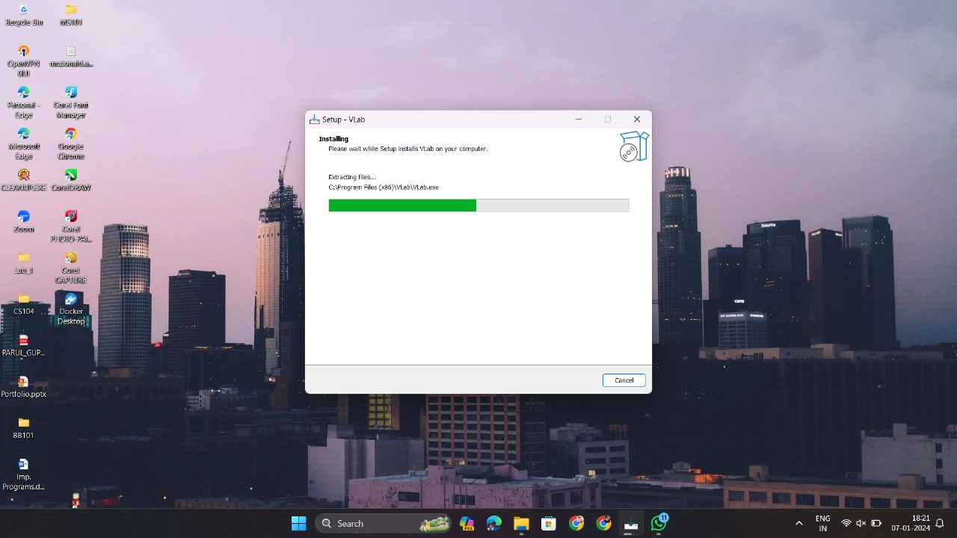

After completing this, you will see this window. Click “Finish,” and the installer finally closes =>

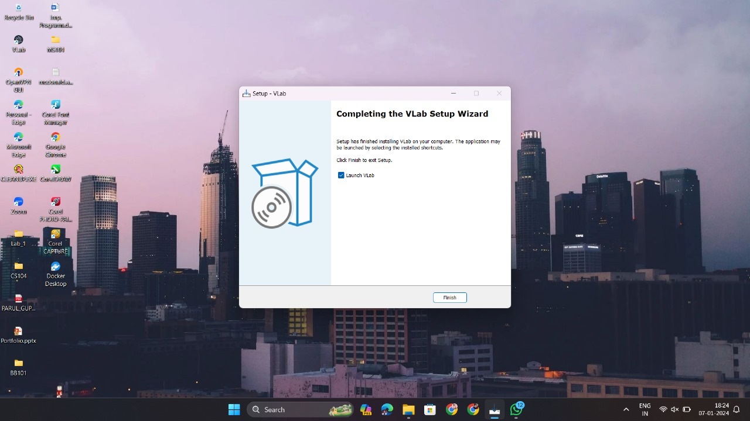

Now, the cLab app has been installed. Here, the installation is completed.

**If all dependencies are installed smoothly, read the note below.**

**IMPORTANT NOTE: Docker Desktop needs to remain open at all times cLab is used.**

Getting Started

**Make sure this process is done in an IITB network (Your LAN, IITB-Wireless, Eduroam, or IITB VPN)**

Step 1: Open the Docker Desktop application. You'll see this window if you’re opening it for the first time. Click “Accept” =>

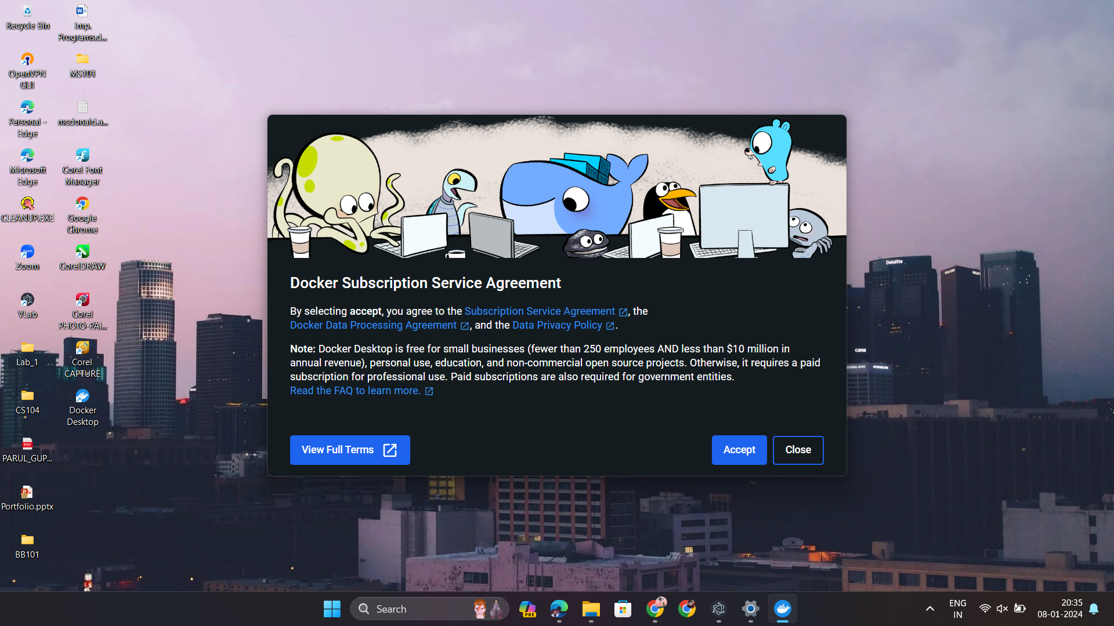

Step 2: You will see this window; click “Continue without signing in” =>

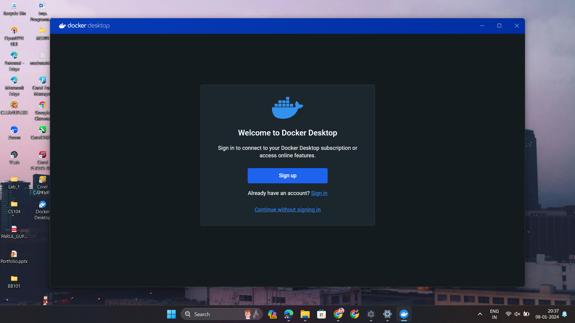

Step 3: Click “Skip” =>

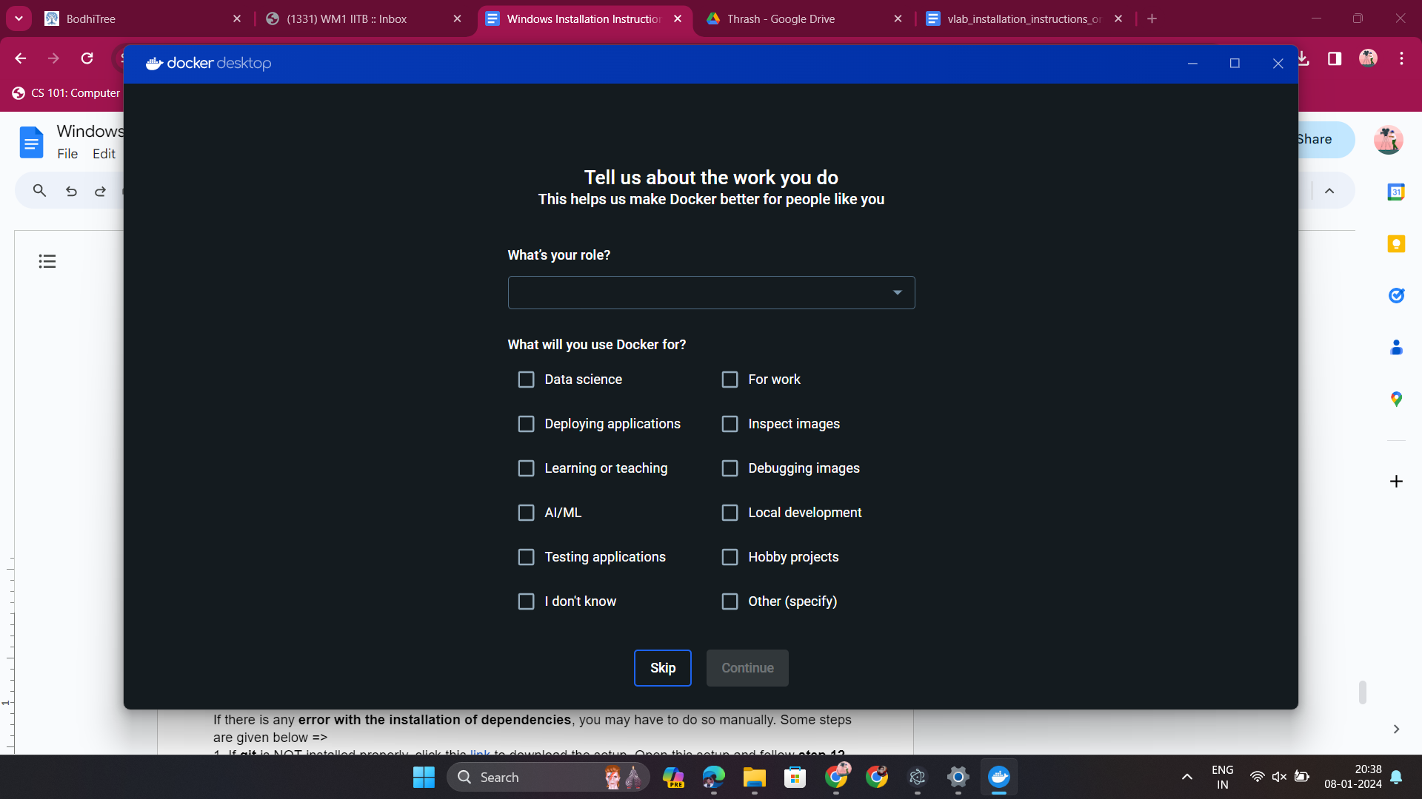

You will see this window =>

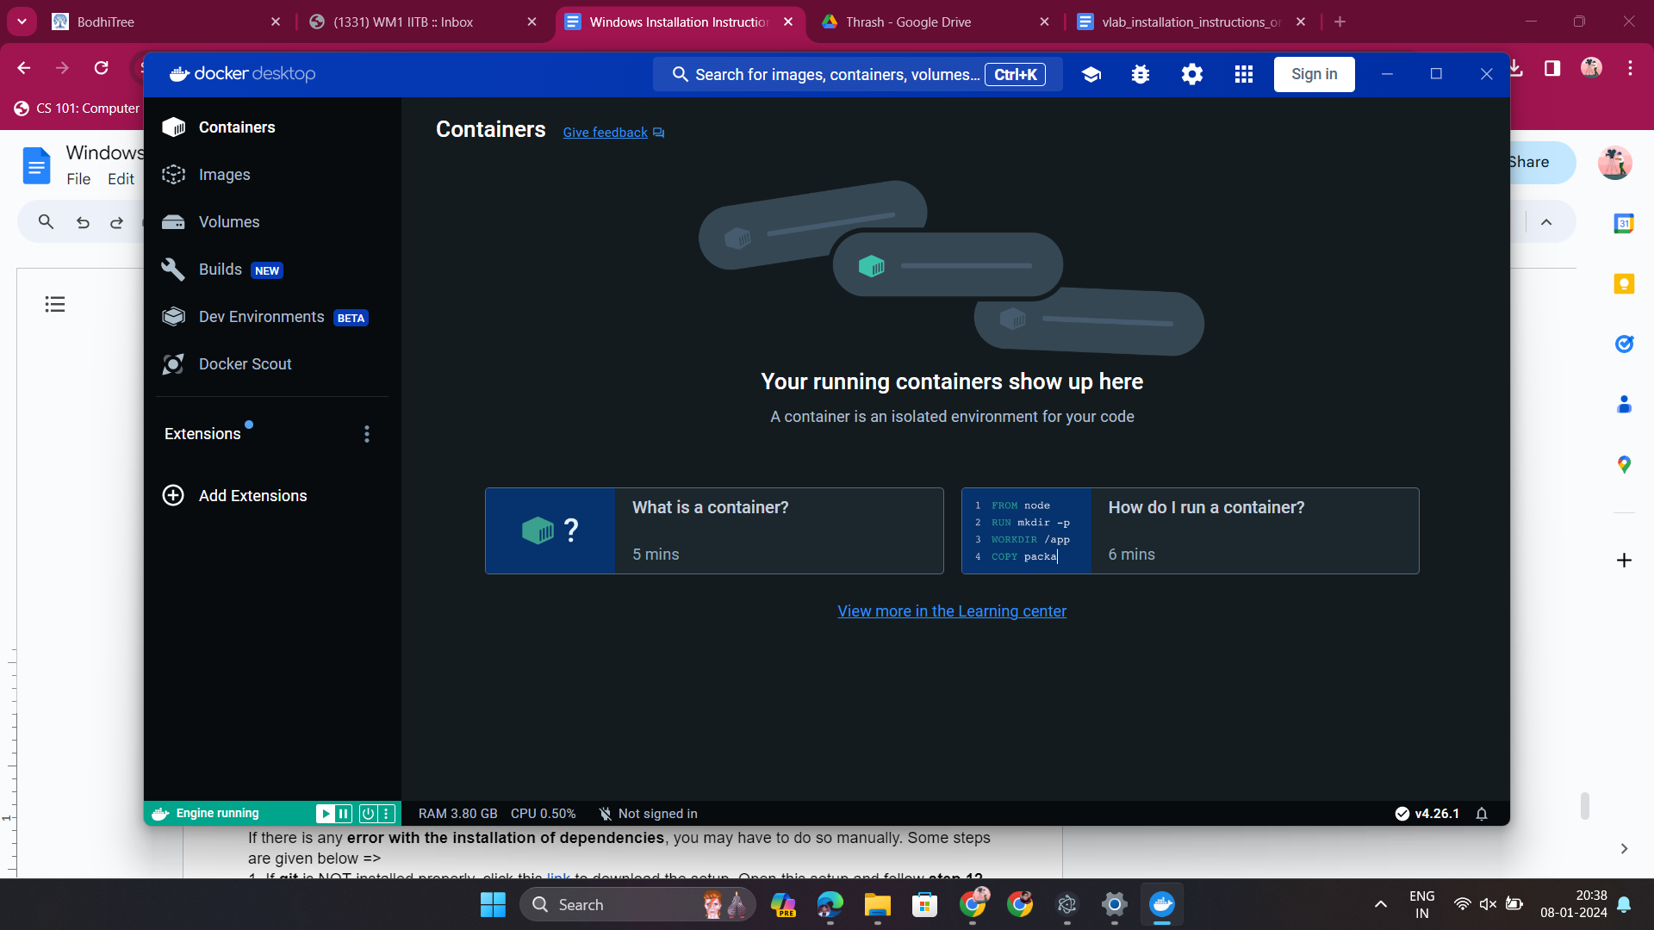

**DON’T CLOSE IT, as long as cLab is being used.**

Step 4: Open the cLab (or VLab) app. Login. And enter “Software Systems Lab” =>

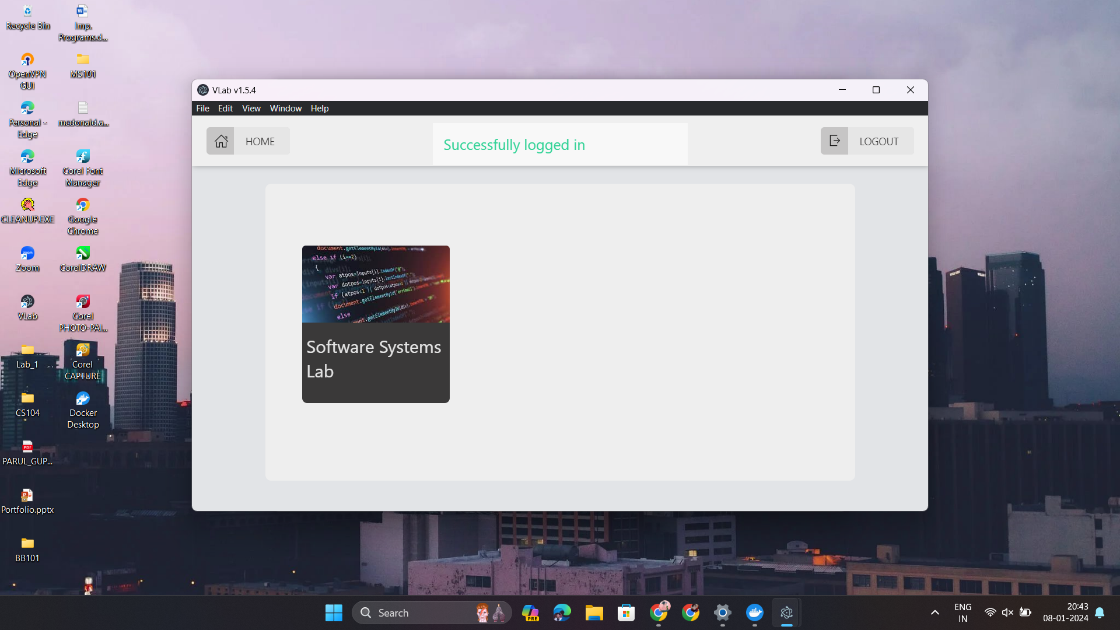

**Step 5 onwards, do DURING the Lab, as Lab-1 will be present then.**

Step 5: Enter “Lab-1” =>

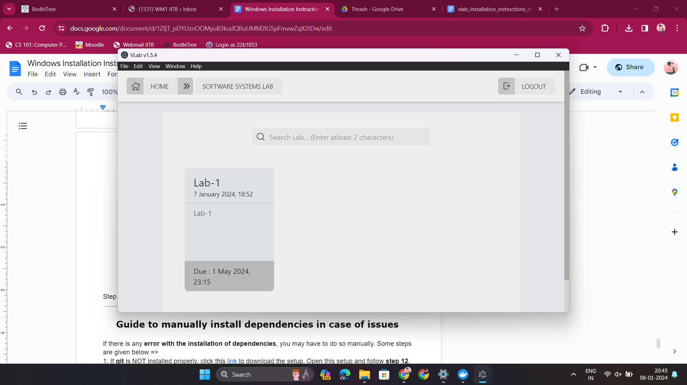

Step 6: Here, you can see the description of this activity. Give it a read. Then click “Attempt” =>

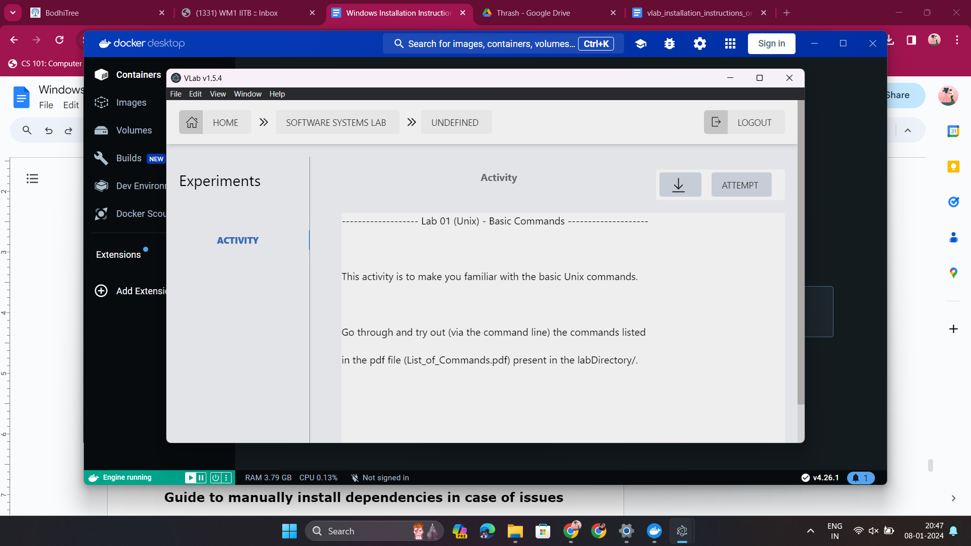

You may see this progress bar. Wait patiently for it to complete =>

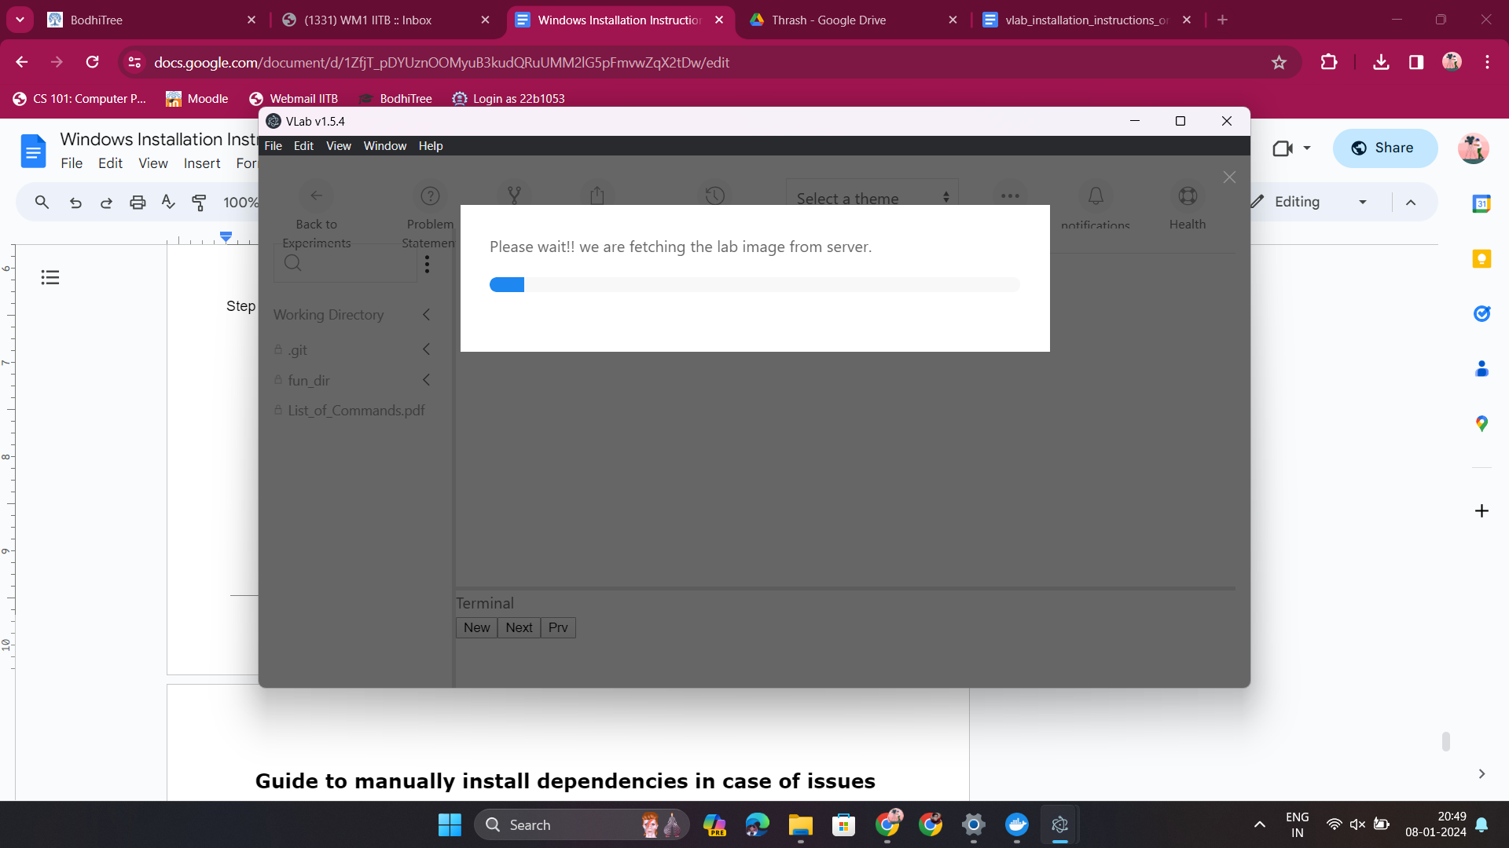

This indicates that the docker image from the server is being loaded on your computer via the Docker Desktop application. That’s why it’s necessary to keep it open at all times.

After completing this, check out the signs below to see that the docker image is successfully built:-

1. Black color bottom terminal should be present
2. The “EVALUATE” button on the middle right should be present
3. Click the “Health” option on the top right, and you should see both options “green” in color

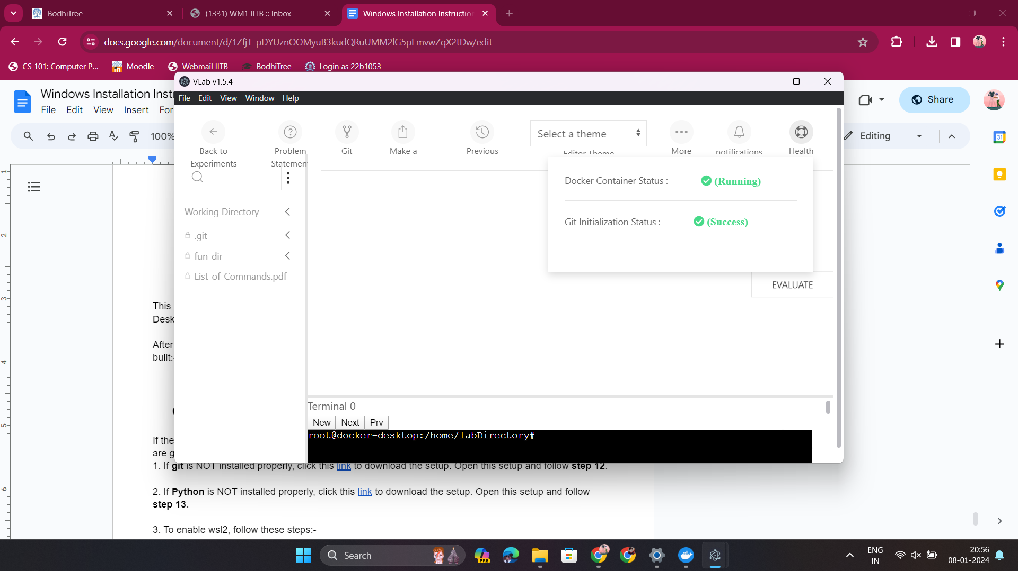

If all these are present in your cLab (or VLab) window, then proceed to the next step; otherwise, call for a TA for help or re-open the activity (ensure Docker Desktop is open).

Step 7: You can read the Problem Statement from the “Problem Statement” option =>



Step 8: Click “More” → “Pop a new terminal” =>

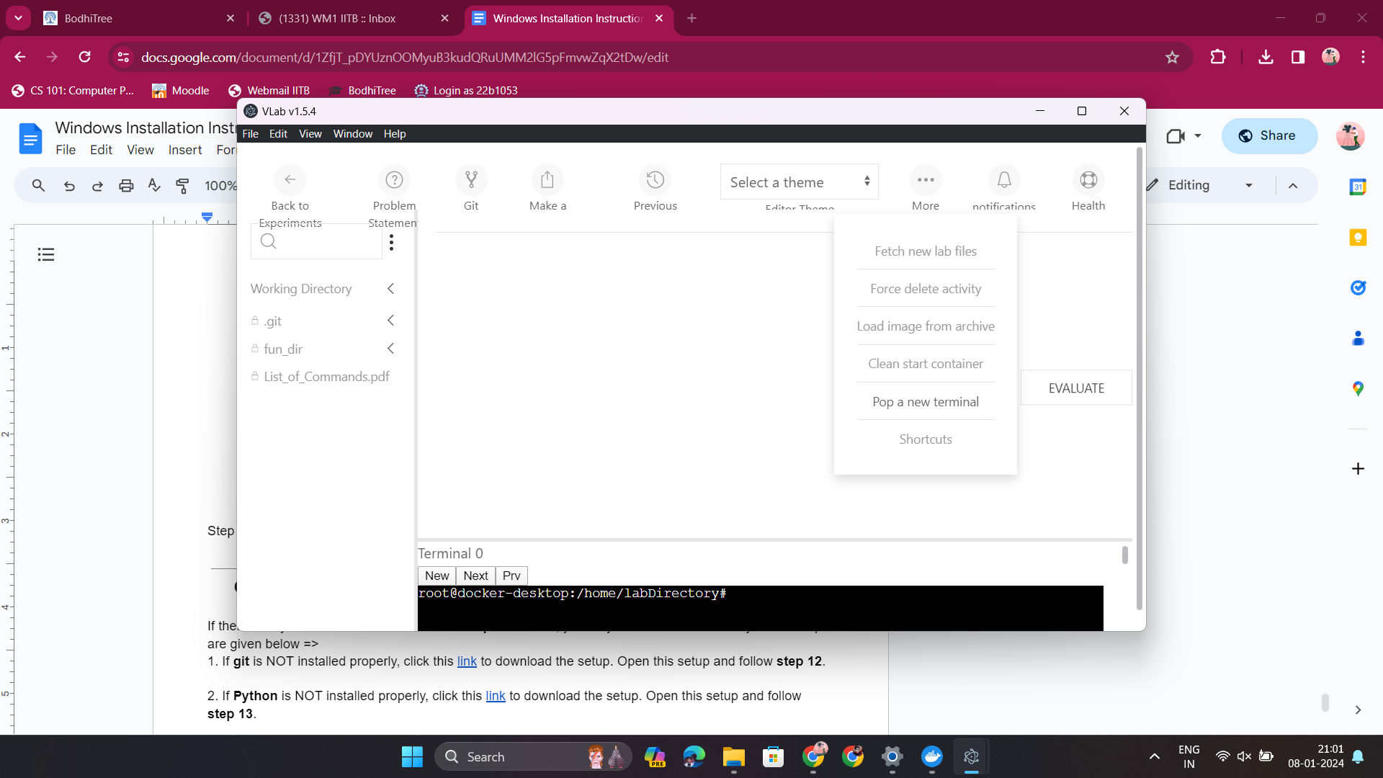

You will see a new pop-up terminal like this =>

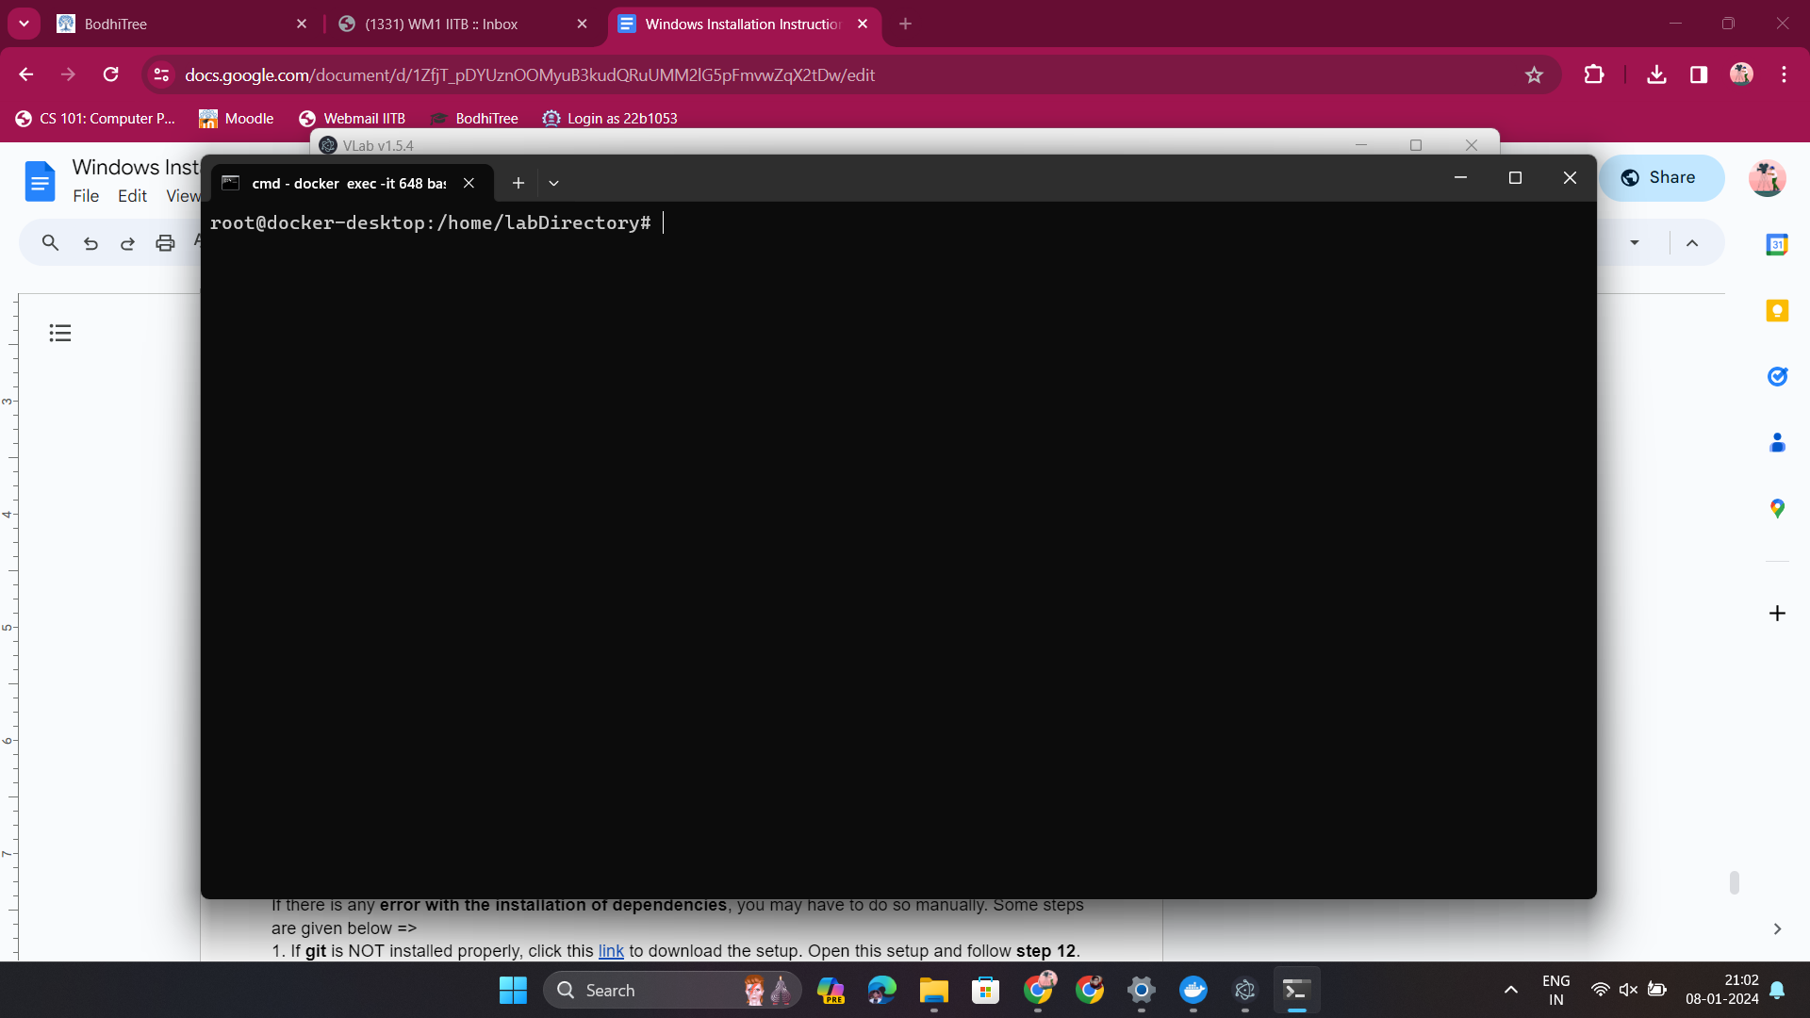

It will automatically open at /home/labDirectory directory. This is the directory where all your question/submission files or any additional files/folders will be located. Note that as soon as you open an activity, cLab (or VLab) automatically opens the /home/labDirectory directory. You can see the directory structure of /home/labDirectory on the left side of the window =>

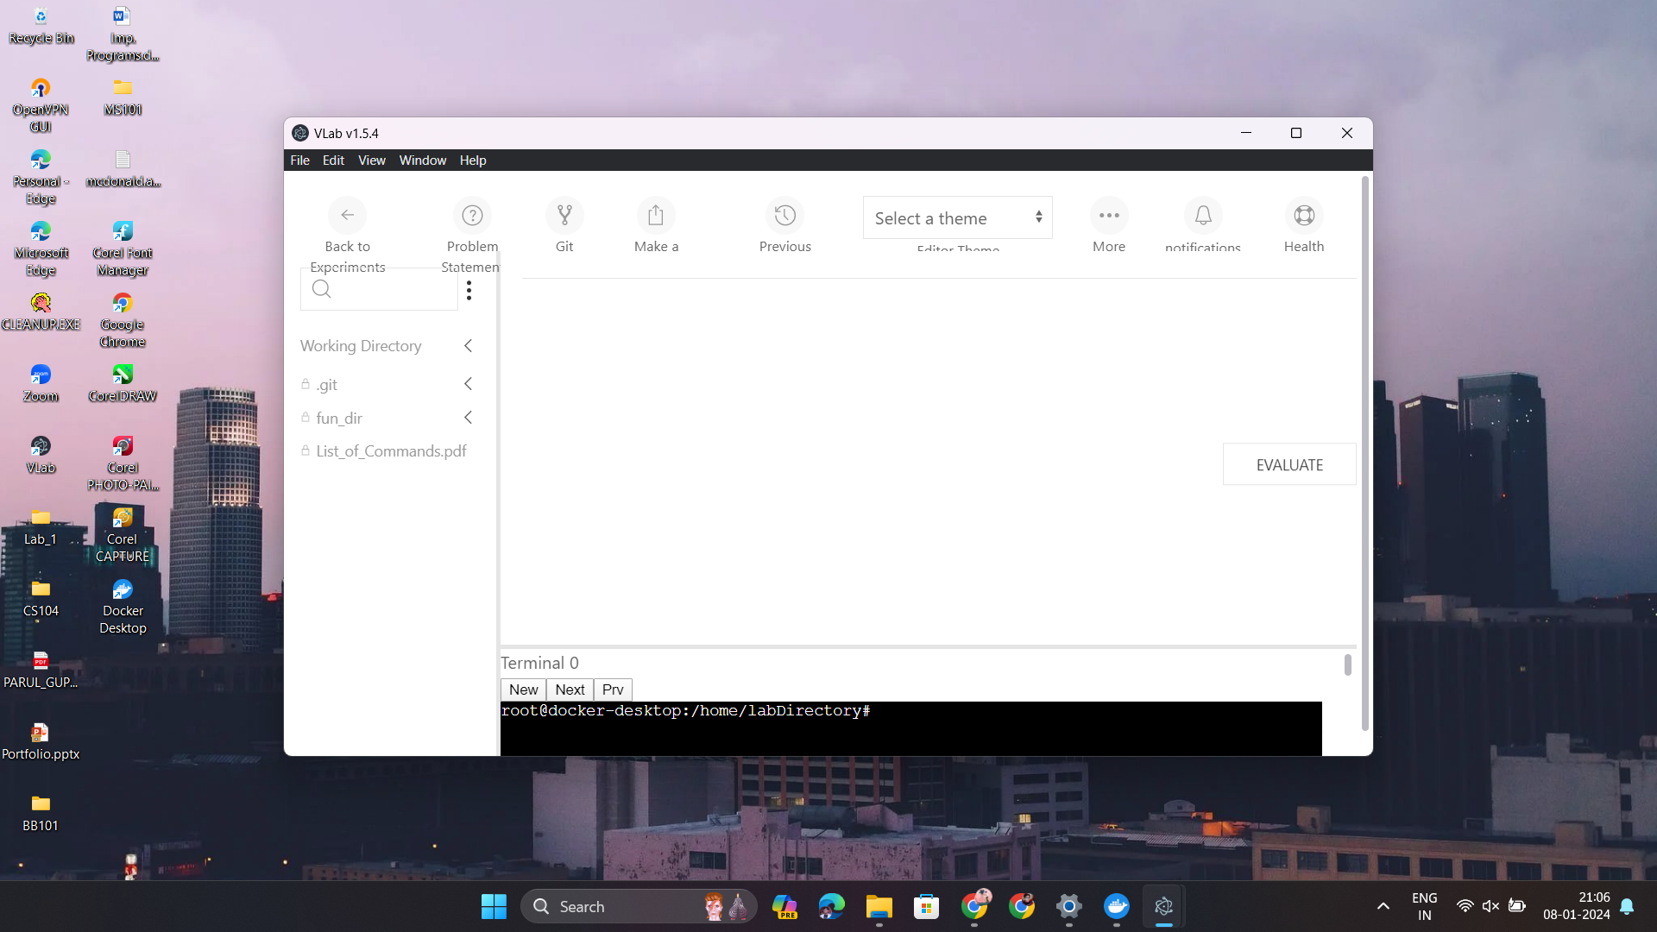

The “fun_dir” has some fun stuff, you can give it a read after this lab ;)

To open any non-text file, click on it on the VLab window and you will see this =>

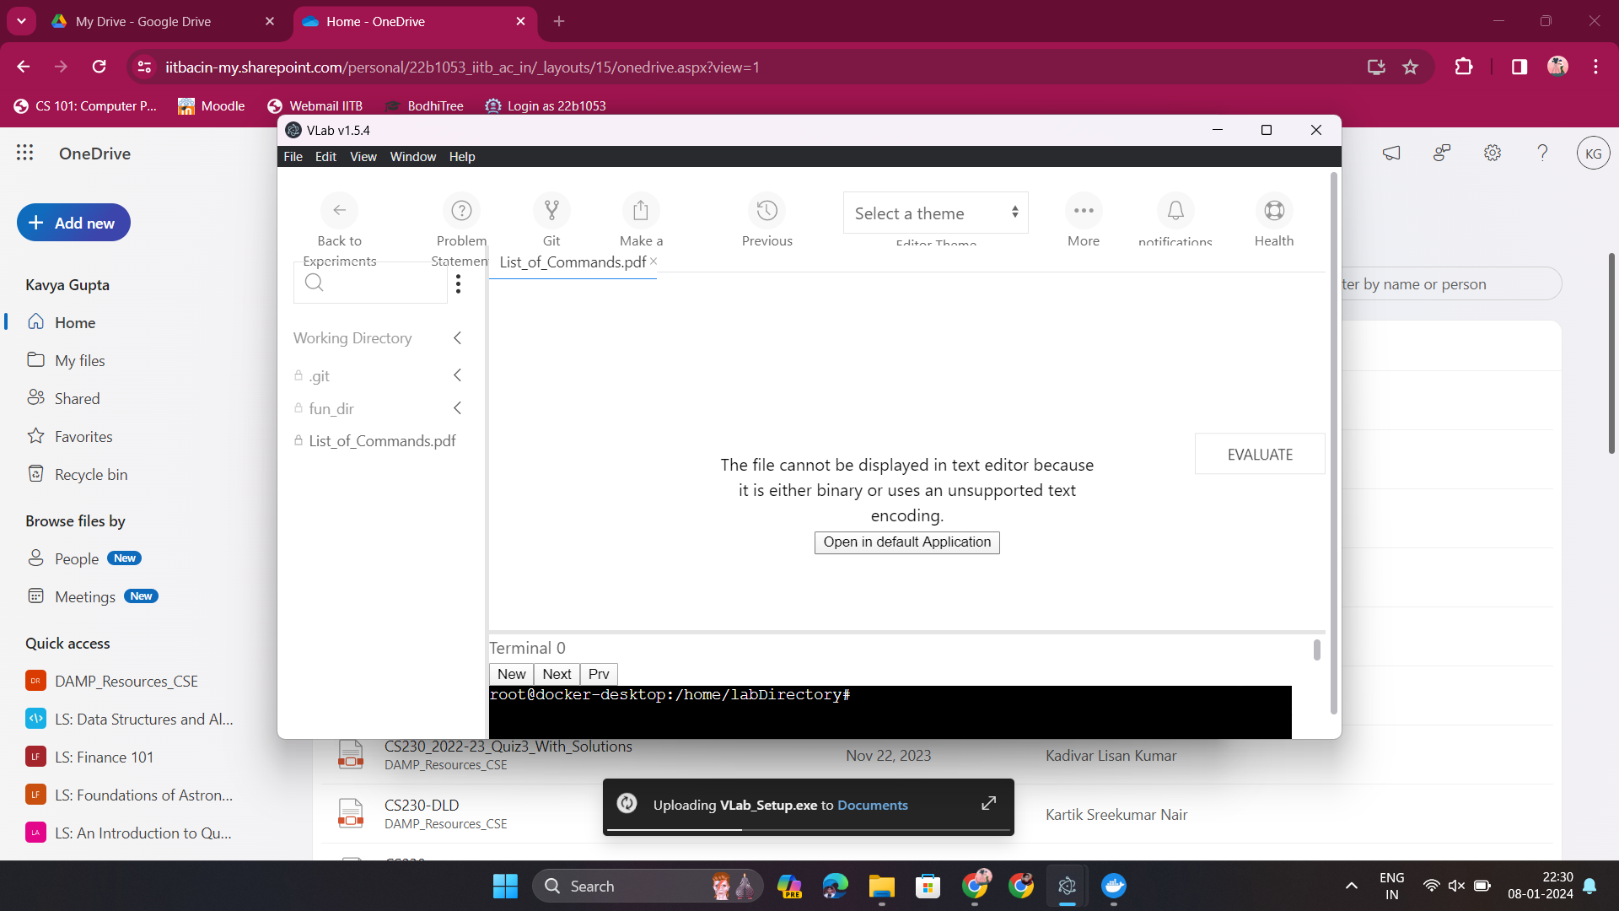

Click on “Open in default Application”. It will automatically open that file in a required application.

Some Important notes:-

1. Do not use the bottom black terminal. Always use “Pop a new terminal”.
2. Always keep Docker Desktop open.
3. If present, ignore .git on the left side of the cLab (or VLab) window.
4. Using cLab (or VLab) in full-screen mode is advised to experience the proper interface.
5. This ‘Lab-1’ will require no submission. Hence, don’t worry about buttons like “Git VCS”, “Make a submission” or “Previous submissions”.
6. You will be given a Bodhitree or Safe Quiz to do after/before this activity.

Now you can finally do the questions 🙂. Refer to the Problem Statement as said here in Step 7.

**Guide to manually install dependencies in case of issues**

If there is any **error with the installation of dependencies**, you may have to do so manually. Some steps are given below =>

1. If **git** is NOT installed properly, click this [link](https://github.com/git-for-windows/git/releases/download/v2.43.0.windows.1/Git-2.43.0-64-bit.exe) to download the setup. Open this setup and follow **step 12**.

2. If **Python** is NOT installed properly, click this [link](https://www.python.org/ftp/python/3.12.1/python-3.12.1-amd64.exe) to download the setup. Open this setup and follow **step 13**.

If **Pop a new terminal** i

You can also try installing Python from Microsoft Store. Follow this [link](https://apps.microsoft.com/detail/9NCVDN91XZQP?hl=en-us&gl=US).

3. To enable wsl2, follow these steps:-

- enable wsl2 (windows 11 or newer Windows 10) <https://learn.microsoft.com/en-us/windows/wsl/install>

- enable wsl2 for older Windows 10 <https://learn.microsoft.com/en-us/windows/wsl/install-manual>

4. If **Docker Desktop** is NOT installed properly, click this [link](https://desktop.docker.com/win/main/amd64/Docker%20Desktop%20Installer.exe) to download the setup. Open this setup and follow **step 14**.

## FAQs

1. “Pop terminal” button not working  
   Install python from microsoft app store [install link](https://apps.microsoft.com/detail/9NCVDN91XZQP?hl=en-us&gl=US)
2. Docker running but activity not loading
   1. Make sure in docker desktop app bottom left corner its written docker engine running in green
   2. Log out click on “Change Server/Workspace Directory” , change workspace directory to any directory of your choice, then login again